DAMNOK TOEK PROTECTION MEDIA AND COMMUNICATION GUIDELINES

Damnok Toek (DT) Child and Vulnerable People Protection Policies are intended to make sure that all of DT’s beneficiaries are protected at all times. Although protection policies regarding media and communication are mentioned in both policies, DT understands more detailed and thorough policies are needed to ensure the protection of all beneficiaries in this regard.

These guidelines are part of both the Child and Vulnerable People Protection Policies and will be integrated to both of them on the upcoming review to be finished by April 2022 and approved by DT’s Board of Directors by June 2022. Due to the immediate need for guidelines for media and communication, this addendum is being developed in November 2021 and will be sent to the Board of Directors for acknowledgement so it can start to be used immediately.

Every DT’s beneficiary has the right to be protected and to have their privacy respected at all times. Therefore, the guidelines below should be observed and followed when creating and using any media/communication content within Damnok Toek:

- Case Management Files
  - All files and child records are strictly confidential and are kept in a safe place.
  - Access to these files can only be granted by DT’s Executive Director or the respective coordinators.

- Case Studies
  - Information for case studies is provided only with written consent from staff or parent/guardian.
  - Individuals should always be kept anonymous - No names and any other personal information (e.g., address, documentation, etc.) should be shared.

- Visitors and Journalists
  - All visitors should sign the additional DT guidelines for project visiting. These conditions can be found in Annex 2 of both the Child and Vulnerable People Protection Policies.
  - All journalists should sign the additional DT guidelines for journalists. These conditions can be found in Annex 3 of both the Child and Vulnerable People Protection Policies.

- Interviews
  - Before any interview is conducted with children, the topic and questions must be discussed and approved by the director and/or coordinators. The director and/or coordinator has the right to change the interview questions or topics if they interfere in the children’s well-being and rehabilitation process.
  - DT’s beneficiaries or parent/guardian should give written consent before doing any interview. No beneficiary should be asked any question before agreeing in participating to the interview.
  - DT’s beneficiaries should be fully aware of the usage of the information and should agree to the way it is distributed.
  - DT’s beneficiaries can stop interviews at any time they want and the interviewer should respect it at all times.
  - Interviews cannot be conducted without the presence of at least one staff member or parent/guardian.

- Photography and filming
  - Staff members are not allowed to take pictures for their “own business” or “own interest”.
  - Every picture needs to have a purpose and should be taken only if:
    - Needed for project activities;
    - Requested by coordinators, directors, or the communication officer.
  - After receiving a picture request from a coordinator, director, or communication officer, the staff member should consider the following flowchart:

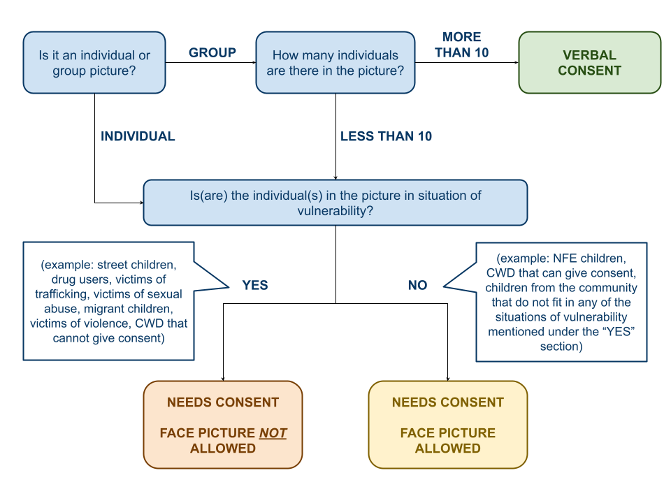
*The same is valid for videos. In this case, consider the number of people that appears together at the same time on the same scene. All participants of videos need to be assessed individually and footage should be taken according to their needs following the picture above.

  - Parent/Guardian or Project Coordinator need to sign the consent in case consent cannot be given by the beneficiary.
  - After taking pictures, staff members should be requested to upload them to a DT device (DT computer, OneDrive, etc. - not personal devices) and delete the photos from the personal phone or camera.
  - Visitors are not allowed to take pictures unless requested in advance.
  - If visitors need pictures in the moment of the visit (not requested in advance), DT staff takes the pictures and sends them to the visitors. DT coordinator or director will check the picture before it is sent to the visitor and will make sure appropriate consent is given.

- Naming and Personal Information
  - Individuals should always be kept anonymous - No names and any other personal information (e.g., address, documentation, etc.) should be shared.

- Social Media
  - Staff is strictly prohibited from posting pictures of beneficiaries in their own social media or any other platforms.
  - Staff is allowed to share posts from DT’s official page.

